Open the TI-Nspire™ document Linear_Quadratic_Inequalities.tns.  In this activity, you will manipulate sliders to examine and interpret the solutions to compound linear and quadratic inequalities. | 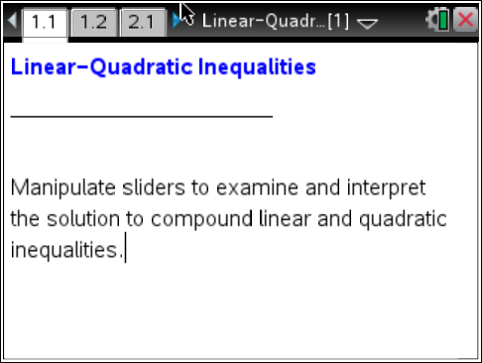

Move to page 1.2.

- Select £ and ¤ to change the values of m and k such that m = 1 and k = –2.

- What do the shaded areas above the parabola and below the line represent?

- Describe the solution of the compound inequality and

- Choose a point in the solution area described in part 1b and show that it satisfies the compound inequality

- How would you explain to a friend what regions to shade if he or she were graphing the inequality by hand?

- Select the inequality to change to Describe the solution of the compound inequality and

- Change the inequality symbol and use the sliders to obtain the solution to compound inequality:
- Describe the solution of

- Use this information to solve the inequality
Explain your reasoning.

- Describe the solution of

Move to page 2.1.

3. Use the sliders to change the values of a, h, and k such that a = 2, h = 1, and k = 0.
- Show how to obtain the coordinates of the two labeled points algebraically.

- Describe the solution of

- What are the domain and range of the points in the solution set?

- Explain how you obtained your answer to part 3c.

- If possible, give values of a, h, and k such that the solution set of the compound inequality is
- a single point

- two points

- the empty set

- Are your answers to question 4 the only correct answers? Explain.

- If the inequalities in question 4 were changed to and would any of your answers change? Explain.

Move to page 3.1.

7. Use the sliders to change the values of m and b such that m = –0.5 and b = 0.
- Write an inequality to represent the shaded area in the interior of the circle.

- Adjust the sliders so that the line goes through the diameter of the circle, and write its equation.

- Is there more than one correct answer to part 7b? Why?

- Write a compound inequality that describes
- the area below the diameter and in the interior of the circle

- the area above the diameter and in the exterior of the circle

