Open or create the TI-Nspire™ document Fixed_Perimeter_Rectangles.tns.  In this activity, you will explore the measurements for side length and area of a rectangle with a fixed perimeter. | 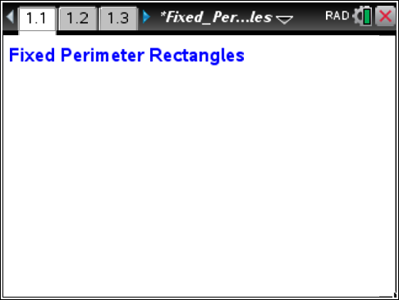

Part 1—Exploring a rectangle with a perimeter of 20 units  - The rectangle at the right has dimensions as shown, where the base (length) = 6 units and height (width) = 4 units.  a. What is the perimeter of the rectangle?  b. What is the area of the rectangle? | 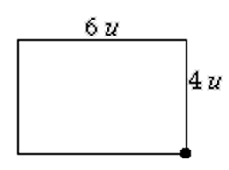
Move to page 1.2.

The rectangle on page 1.2 of the .tns file should have the same dimensions as the rectangle in problem 1. If necessary, move the point at the lower-right vertex to make the rectangle match the one shown above. | 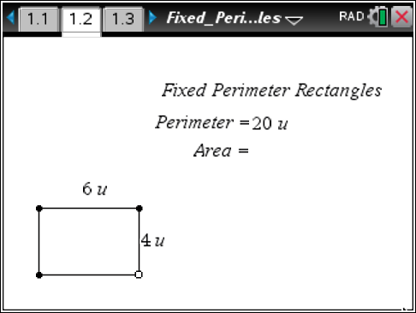
2. Press Menu > Geometry > Measurement > Area. Move the cursor near the rectangle until the word polygon is displayed. Press x. Move the measurement and place it to the right of “Area =.” Press ·. Press d. Does the measurement match your answer to question 1b? | 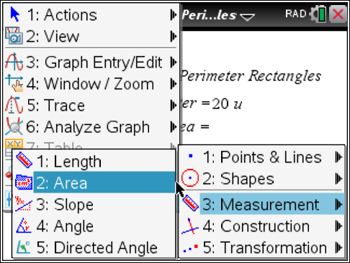
3. Grab the point at the lower-right vertex of the rectangle and change the dimensions so that the rectangle is 6.5 units by 3.5 units.  a. What is the displayed area for this rectangle? Is the area measurement correct? Why or why not? | 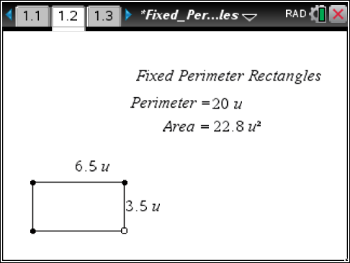
b. Move the cursor over the area measurement of 22.8 u² until the word text is displayed. Right-click (/ b), and choose Attributes. Press ¢ to increase the displayed measurement to 4 digits. Press ·. Is the new area measurement correct? | 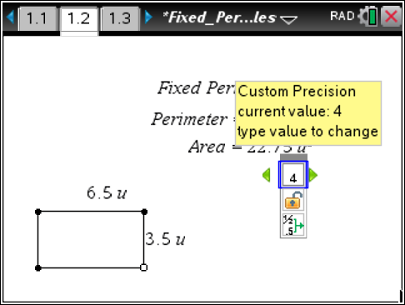
4. Record data for four different rectangles. Grab the point at the lower-right vertex of the rectangle to change its dimensions. Record the data in rows 1–4 in the table. Use the last row in the table to generalize the relationships.
 | Base  (units) | Height  (units) | Perimeter  (units) | Area  (sq. units)
Rectangle 1
Rectangle 2
Rectangle 3
Rectangle 4
Rectangle n | n

5. Examine the data in the table. Describe your observations. What patterns or relationships do you observe?

6. Grab the point at the lower-right vertex of the rectangle to change its dimensions. Watch the measure of the area as you change the rectangle. What are the dimensions of the rectangle with the greatest area with a fixed perimeter of 20 units?

Part 2—Exploring rectangles with a different perimeter  To change the perimeter of the rectangle, move the cursor over the value 20 until you see a hand (÷) and the word text. Press x twice to open the text box. Press . to delete the current value. Type in a new perimeter value, and then press ·. (Choose a perimeter value between 8 and 35 units for best viewing on the screen.) Note: When the perimeter value is changed, the rectangle may disappear. Grab the open point and slide it until a rectangle appears. | 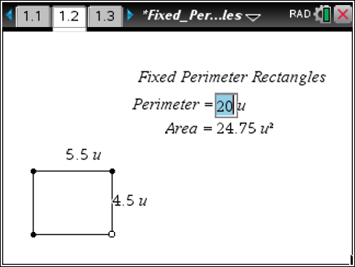
7. Grab the point at the lower-right vertex of the rectangle to change its dimensions. Record the data in rows 1–4 in the table. Use the last row of the table to generalize the relationships.
 | Base  (units) | Height  (units) | Perimeter  (units) | Area  (sq. units)
Rectangle 1
Rectangle 2
Rectangle 3
Rectangle 4
Rectangle n | n |  | p

8. Examine the data in the table. Describe your observations. What patterns or relationships do you observe?

9. A rectangle has a perimeter of p units and a base of b units.
- Write an expression to represent the height, h, of the rectangle.
h = _____________
- Write an expression to represent the area, a, of the rectangle.
a = _____________

