Problem 1 – Cost per person for a pizza order
The coach of the football team wants to order individual pizzas to eat after their game. Pizza-To-Go charges $5 for each individual pizza, plus an overall delivery charge of $7. The coach needs to figure out the cost per player so that each player who wants pizza can contribute enough to cover the total cost.
- What do you think will happen to the cost per player for pizza as more team members decide they want to order pizza?

- Calculate the average cost per player in L2. Is your prediction correct?

- Write a function for the cost per player.  - Graph your function as Y1. Sketch the graph on the coordinate grid to the right. | 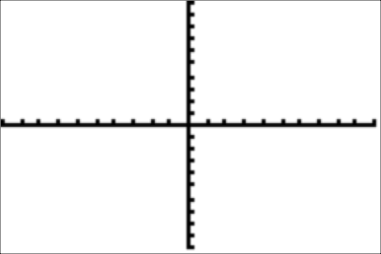
- As the number of players increases, what happens to the cost per player? What number does the cost per player approach? Explain what this means in the context of the problem.

Exercise 2 – Investigating end behavior
Graph in Y1.
- Change the window so that the x-axis goes from –500 to 500. What happens to the graph?

Investigate the behavior of f(x) using either by calculating values of Y1 or viewing a table of values. Enter 10, 100, and 1000 and then –10, –100, and –1000 to simulate the x-values going to positive and negative infinity, respectively.
- What happens to the y-values in the table as the x-values get larger? Get smaller?

- What value is f(x) approaching as x approaches infinity?

- How is this supported by your graph?
Graph in Y1.
- Extend the axes of the graph as before. What do you notice?

Investigate the behavior of g(x) using either by calculating values of Y₁ or viewing a table of values. Choose several values of x to explore.
- What value is g(x) approaching as x approaches infinity?

Graph in Y1.
- Adjust the window as done in previous exercises. What do you observe?

Investigate the behavior of h(x) as before.
- What is the end behavior of h(x)?

Graph in Y1. (You will need to adjust the window to view the shape of the graph.)
View a table of values to investigate the values of j(x) as x gets larger and smaller.
- What is the end behavior of j(x)?

Graph in Y1.
Again, view the function table to investigate the values.
- What is the end behavior of k(x)?

Graph in Y1.
Calculate values of Y1 on the Home screen to investigate the values of m(x) as x gets larger and smaller.
- What is the end behavior of m(x)?

Bringing it all together
- Summarize how you to find the end behavior of a rational function on a graph. How about on a table? What is end behavior in your own words?

Recall the end behavior of the following functions from this activity:
Function
End Behavior | y = | y = | y = | y = | y =

- Based on what you observe in the above examples, what do you think is the end behavior of the function ?
- What is the end behavior of a rational function of the form where b and d are any integer and a and c are any nonzero integers?

Extension
Examine the end behavior of the function .

