Proportions from two independent populations can be compared. Subscripts 1 and 2 are used in the notation to distinguish between them.
x₁, n₁, and x₂, n₂,
A confidence interval for the difference between two population proportions is
() – E < p₁ – p₂ < () – E, where the margin of error is E =
Problem 1 – Estimating a Confidence Interval
Customers randomly selected at a grocery store included 172 women and 445 men. Of the women, 74 used coupons, as did 12 of the men.
What is the difference between the proportion of women and the proportion of men that use coupons at this store?
Calculate the two proportions and then find the difference between them.  Store as A, as B, and as D.  To store a value, press  and then enter the letter. | 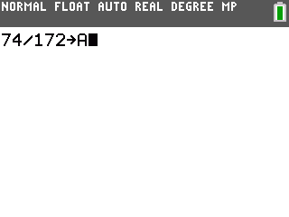
Find the Margin of Error at the 95% level and store it as E.  First use the invNorm command to find the z-score. This command is found in the DISTR menu ( ).  Use the margin or error and the difference of the proportions to find the 95% confidence interval. | 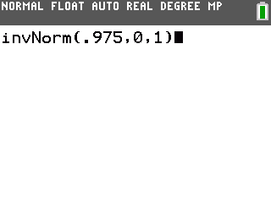
- State the confidence interval in a sentence.
- Now find a 90% confidence interval for the same proportions.
Check your answers using the 2–PropZInt command. Press , arrow over to the TESTS menu and then scroll down to select the command. | 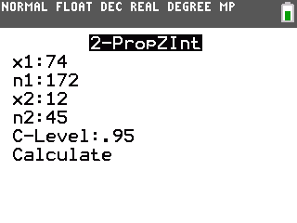
Problem 2 – Practice Problems
A principal reported that the same percent of juniors and seniors felt that the homecoming should have been postponed due to rain. A student checks this claim by randomly surveying 85 juniors and 57 seniors. Respectively, 66 and 40 of those students said homecoming should have been postponed.
- Find the 95% confidence interval for the difference between the proportions.

- What do you think of the principal’s claim?

In an experiment for a new drug, 217 patients took the drug and 58 of those reported headaches, while 174 patients took the placebo and 66 of those reported headaches.
- Find the 95% confidence interval for the difference between the proportions, where is the proportion for the placebo and is for the drug.

- Is there reason to believe a side effect of the new drug may be headaches?

Problem 3 – Sample Size
The required sample size to find the difference between two population proportions is given by using the formula at the right. When an estimate of a sample proportion is unknown, 0.5 is used.
Suppose you want to know the difference in proportion of men and women that shop for new cars online
- Find the required sample size of each sample. You want a 95% confidence level and a margin of error of no more than 4%.

- Find the required sample size when the margin of error is changed to 2%.

Problem 4 – Extension
Use E = to derive the formula for sample size n.
Begin by replacing n₁ and n₂ with n.

