Open the TI-Nspire document Application_of_Polynomials.tns.  This activity uses the volume formula to find cubic polynomials in order to determine the dimensions of four different-size boxes used for packaging trash bags. Graphical representations are used to find the zeros of the polynomials. | 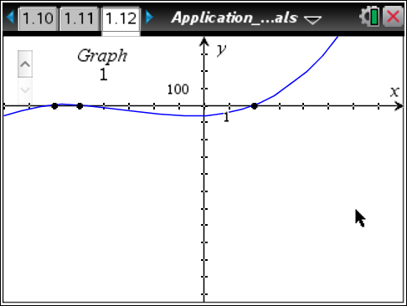

Move to page 1.2.

The Burly Bag Company manufactures trash bags in four different sizes. The bags are rolled together and then packaged in a rectangular box (right rectangular prism). In the diagram on page 1.3, l, w, and h represent the length, width, and height of the box, respectively. To cut down on packaging costs, the company has decided to put fewer bags in each package in order to make the boxes smaller. For the new boxes, the height must be 1 inch larger than the width, and the length must be 8 inches longer than it is wide.

Move to page 1.3.

1. Using the information given, represent the length, width, and height of the box. Use x for the variable.
Length | Width | Height

2. Using the results from Question 1, what formula would be used to find the volume of the box? Showing your work, write the expression in expanded form.

Move to page 1.8.

3. The results from Questions 1 and 2 are shown in the diagram on page 1.8. Why was x chosen to represent the width of the box and not the length or the height?

The box volume requirements for each type of bag are listed below.

Type of Bag | Box Volume (in³)
small | 60
tall kitchen | 240
large lawn | 390
contractor | 840

4. Using the information above and the volume formula from page 1.8, represent the volume of the box for each type of bag as an equation.

Type of Bag | Volume Equation
small
tall kitchen
large lawn
contractor

What type of polynomial functions are these equations?

Move to page 1.12.

Page 1.12 shows the graphs of the polynomial equations for each type of bag. Use the up and down arrows to see all four graphs. These graphs can be used to determine the width of the box for each bag type.
5. On page 1.12, the points on the graphs indicate where the polynomial intersects the x-axis (zeros). Write the zero(s) for each graph in the table below.
Graph # | Zero(s)
1
2
3
4

What do these values represent?

6. Showing your work, determine which zeros belong to each of the polynomial equations from Question 4 using substitution.

Graph # | Polynomial Equation | Box Type | Substitution | Zeros
1

2
3
4

7. Which of the three zeros on graph 1 represents the width of the box? How can you tell?

8. Now that the width of each of the four box sizes has been determined, find the other dimensions for each box. Show your work in the table.
Box Type | Length  (x + 8) | Width  x | Height  (x + 1)
small
tall kitchen
large lawn
contractor

9. Check the dimensions you found for each of the four different-size boxes by using the volume formula (V = l ∙ w ∙ h). The volumes should match the values given on page 1.9. Show your work.
Box Type | V = l ∙ w ∙ h
small
tall kitchen
large lawn
contractor

