Goal: Use to estimate p, where p is a population proportion and is a sample proportion.
, where x = number of successes and n = number of observations
Problem 1 – Margin of Error and a Confidence Interval
A surveyor randomly selects 350 registered voters and asks if they support a proposed bill. There were 293 voters that said yes.
1. Find.

Margin of Error | Confidence Interval

To calculate a confidence interval for the true proportion of voters who support the proposed bill, follow Steps A to D.
Step A: Find the critical value by using the invNorm command in the DISTR menu (y½).  Step B: Use the formula to calculate the margin of error.  Step C: Calculate the confidence interval.  Step D: State your findings in complete sentences. | 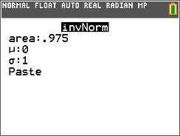
2. Find a 95% confidence interval. State your findings.

3. Find a 99% confidence interval. State your findings.

The calculator allows this confidence interval to be found without having to first find the critical value and margin of error. Press …, right arrow to the TESTS menu and choose 1-PropZInt. Then enter x, n, and the confidence level. Use this command to check the 95% and 99% intervals you just found. (Answers may be slightly different due to rounding.) | 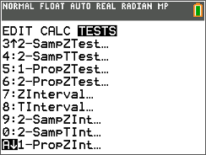
Problem 2 – Practice Problems
A reporter made the claim that at least 80% of teenagers in the city went to the mall at least once per week. A researcher wants to check that claim and randomly surveys 437 teenagers in the city. She finds that of the teenagers surveyed, 316 go to the mall at least once per week.
4. Find a 95% confidence interval for the true proportion of teens that go to the mall at least once per week.

5. What do you think of the reporter’s claim?

A principal reported that one-third of the student body would support switching to a year-round schedule. A student checks that claim by randomly selecting and surveying 65 students. He found that 24 of those students would support switching to a year round schedule.
6. Find a 90% confidence interval for the true proportion of students who support the switch.

7. What do you think of the principal’s claim?

Problem 3 – Sample Size
The formulas used for estimating the sample size that must be taken to estimate a population proportion with a given margin of error are:
Estimate of Not Known | Estimate of Known

With a margin of error of no more than 2%, a surveyor wants to estimate, with a 95% confidence interval, the percent of citizens in a city that support building a new bridge.
8. How many citizens must be surveyed?

9. Suppose previous polls suggest that 22% of the citizens support building a new bridge. How many citizens must be surveyed?

Problem 4 – Extension
10. Complete the table. | 11. Use the values in the table to explain the derivation of the formula used when no estimate of is given.
  0.1
  0.2
  0.3
  0.4
  0.5
  0.6
  0.7
  0.8
  0.9

