Part 1 – Estimate Vs. Actual Time
When Brian dropped his watch to the bottom of the lake, he had to hold his breath long enough to dive down nearly 20 feet, locate the watch, grab it, and swim back to the surface. Could you hold your breath long enough to retrieve the watch? Which of your classmates are best suited for this task? Use this activity to help you explore the answers to these questions.
1. How long do you think Brian would need to retrieve the watch?
2. How long do you think you could hold your breath in seconds?
3. What are your actual three trials? Trial 1: _________ Trial 2: _________Trial 3: _________
4. Create a scatter plot of the estimates (Question 2) as the x-coordinate and the longest actual trial (Question 3) as the y-coordinate. The plot should have one point per student.  To do this, enter the x-coordinates in L1 and the y-coordinates in L2. Press S and select 1:Edit…. If there are already values in the lists, move to the top of each list and press C e.  Set up an appropriate viewing window and press %.  Draw your scatter plot at the right. Add your scale to the graph and label the axes.  5. With your partner, determine what the scatter plot tells you about the estimates made and the actual times people could hold their breaths. Summarize your observations. | 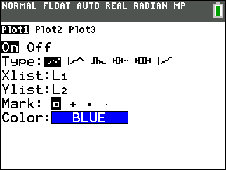  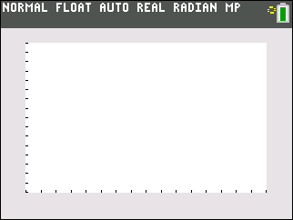
6. What do you think the graph would look like if each person estimated the time they could hold their breath exactly?

Part 2 – X-Y Line
7. Copy L2 into L3. Go to the top of L3 and press ` æ. Then, set up Plot2 as you did in Question 4 but graph L2 versus L3. When you press %, what do you notice?

8. Draw your new scatter plot at the right. Add your scale to the graph and label the axes.
9. Turn Plot1 back on. Press $ and move to one of the points in Plot1 above the points in Plot2. What does this point above Plot2 tell you?

10. Now, press $ and move to one of the points in Plot1 below the points in Plot2. What does this point below Plot2 tell you?

11. Overall, is there a trend in the data?

12. In Brian’s watch situation, which student would be best to help and why?

Part 3 – Box Plots
13. Now, create a box plot of the estimated data and the actual data. Change Plot1 to select the ∆ symbol for the plot type and L1 (estimated data). Change Plot2 to select the ∆ symbol for the plot type and L2 (actual data).Draw your box plots at the right. Add your scale to the graph and label the axes.
14. What does the box plot for the estimates tell you? Press $ to explore the graph.

15. What does the box plot for the actual data tell you?

16. What do the box plots show about how the estimates compare to the actual data?

17. Thinking about Brian’s watch situation again, which data show(s) the student(s) in your class that would be best to attempt the rescue? Why?

