Open the TI-Nspire document Effective_Blocking.tns.  In this activity, you will determine which of three different experimental designs—one completely randomized design and two randomized block designs—would be most beneficial in selecting an effective mosquito treatment. | 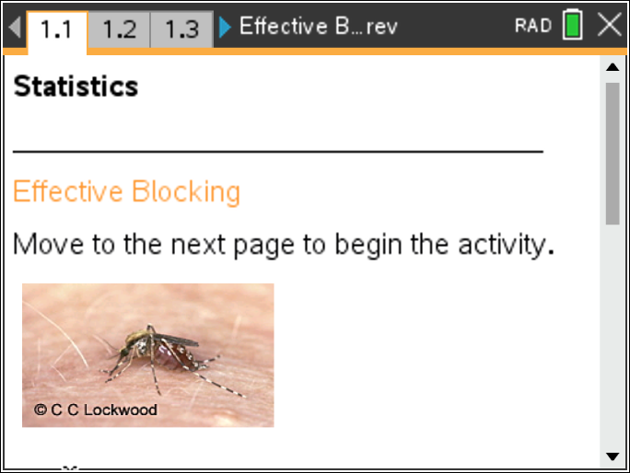

Move to page 1.2. | Press / ¢ and / ¡ to navigate through the lesson.
Pages 1.2 and 1.3 contain directions to “seed” your handheld for the activity.
Kate is a realtor who needs to sell 36 lots, some of which are bordered on one side by a swamp. Because of the swamp, the land is known to have a large number of mosquitoes.
Kate has researched different types of mosquito sprays in her quest to decrease the number of mosquitoes and make the land more attractive to buyers. She has permission to conduct an experiment on only eight of the lots to determine which of the top two sprays would be the most effective in reducing the number of mosquitoes. She decides to simulate some experiments to determine how she might proceed.

Move to page 1.4.

1. On this page, click the initialize arrow once to initialize the activity and select Kate’s eight lots.

Move to page 1.5.

The first method Kate simulated was a completely randomized design. The left work area of the page displays the eight lots of land she will use for her experiment (the ones you generated on Page 1.4).
2. Now, click the right arrow above the grid one time to randomly allocate mosquito treatments (spray A and spray B) to the eight selected lots. Four lots will randomly be assigned to spray A (pink), and four will be randomly assigned to spray B (blue).
- The numbers in the selected lots represent the simulated numbers of mosquitoes a week after the lots were sprayed.
- The bar graph in the right work area shows the average number of mosquitos found after each spray was applied.
- Beneath that is a calculation of the difference between the means of the two sprays, mean(spray A) – mean(spray B), in the number of mosquitoes remaining in each lot.
a. Does a larger or smaller number of mosquitoes indicate a more effective spray? Explain.

b. Note the number of live mosquitoes in each of the lots. What conjecture might seem reasonable?

c. Does there appear to be a difference in the mean number of live mosquitoes for the two treatments? Explain your reasoning.

d. How would you interpret $\bar{x}a−\bar{x}b$ < 0?

3. a. Click the right arrow above the grid again to see another simulation of a possible random treatment allocation. How does this new sample change your answers to questions 1b and 1c above?

b. Click the arrow to create about 23 more simulations, each time observing the number of live mosquitoes in the lots on the grid and in the bar graph. What are the noticeable patterns in the number of mosquitoes? Explain your reasoning.

Move to page 1.6.

4. The plot on Page 1.6 represents the differences (mean Spray A – mean Spray B) in the number of mosquitoes for each random allocation of treatments you generated on Page 1.5.
a. What does the vertical line in the plot represent in the context of the problem?

b. What does a positive value in the dotplot of accumulated data indicate in the context of mosquitoes? What does a negative value indicate in the context of mosquitoes?

c. What is the meaning of the difference between 0 and the mean? Explain your answer.

d. Describe the variability in the mean differences using randomized sampling.

e. Would you consider one mosquito spray to be more effective than the other at reducing the number of mosquitoes?

f. In addition to the type of spray used, name another factor that might affect the number of mosquitoes present on Kate’s land.

Move to page 1.7.

Pooja has an idea for Kate. Since many mosquitoes seem to be near the swamp, she wants to divide the lots vertically down the middle so that each block would have an equal number of lots close to the swamp. Then she will randomly assign the sprays within the two blocks.
5. On this page, click the right arrow in the left panel to randomly assign the treatments, spray A and spray B, to the lots within each of the blocks in Pooja's design.
a. Inspect the bar graphs. Does there appear to be a difference in the mean number of live mosquitoes for the two treatments? Explain your reasoning.

b. Interpret each of the three expressions in the lower right corner of your screen.

bk1: $\bar{x}a−\bar{x}b$
bk2: $\bar{x}a−\bar{x}b$
total: $\bar{x}a−\bar{x}b$

c. Click the arrow 24 more times, each time observing the number of live mosquitoes in the lots on the left and the bar graph on the right. What observations can you make about the number of live mosquitoes for each spray?

Move to page 1.8.

6. The plot on this page represents the mean differences, mean(Spray A) – mean(Spray B), in the number of mosquitoes from the simulations you generated on Page 1.7. Would you consider one mosquito spray to be more effective at reducing the number of mosquitoes than the other? Explain your reasoning.

Move to page 1.9.

Sean wonders whether it would work to divide the land horizontally at the middle so that the lots closest to the swamp are in the same block. He then randomly assigns the sprays within the two horizontal blocks.
7. On this page, click the right arrow above the grid to randomly assign the treatments, spray A and spray B, to the lots within each of these two blocks. The bar graph on the right shows the difference in the number of mosquitoes within each block that are still alive.
a. What do you observe from the bar graphs?

b. Click the arrow 24 more times, each time observing the number of live mosquitoes in the lots on the left and the bar graph on the right. What observations can you make about the number of live mosquitoes for each spray?

Move to page 1.10.

8. The plot on this page represents the mean differences, mean(Spray A) – mean(Spray B), in the number of mosquitoes from the simulations you generated on Page 1.9.
a. What is the median of the distribution, and how would you describe it in the context of the problem?

b. Is your conclusion from the horizontal blocks different from your conclusion based on the vertical blocks? Explain.

Move to page 1.11.

9. This page shows boxplots of the mean differences in the numbers of living mosquitoes from the designs that Kate, Pooja, and Sean suggested—completely randomized design, vertical blocks, and horizontal blocks.
a. Compare the medians of the boxplots of the three experimental designs.

b. Compare the variation in the boxplots of the three experimental designs.

10. Spray B kills on average ten more mosquitoes per lot than spray A. Based on your simulations for the three methods, discuss the likelihood of making an incorrect decision about which spray is more effective?

11. a. The goal of the experiment was to determine which mosquito repellent is more effective at reducing the number of mosquitoes on Kate’s land. Kate will only get to run her experiment one time. Which method, completely randomized, horizontal blocking or vertical blocking, should she chose for the experiment, and why?

b. When Sean studied blocking, he learned that the experimental units within each block should be as alike as possible. How do the results on Page 1.11 support this requirement?

