Problem 1 – Point-Slope Form of the Equation
Point-slope form might look like this in a textbook:
y – y₁ = m(x – x₁) or y = m(x – x₁) + y₁

- What does m represent?

- How does the ordered pair (x₁, y₁) appear in the equation?

- What is the slope of y = –2(x + 1) + 3?

Run the Transformation Graphing Application by pressing  and selecting Transfrm.  Press □ and enter A(X–B)+C next to Y1. Press  and select ZStandard to view the graph.  A = m B = x₁ C = y₁  Use the up and down arrow keys to move between variables. To change the value of a variable, enter the number and then press  or use the left and right arrow keys. | 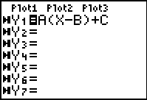
- How do the values of m, x₁, and y₁ affect the graph?

- For the equation y = 4(x – 1) + 3, what is the slope and a point on the graph?

- For the equation , what is the slope and a point on the graph?

Problem 2 – Oh, Baby!
Your neighbors adopted a baby! The baby weighed 20 pounds at 1 year old. The baby is now 2 years old and weighs 31 pounds.
- Calculate the slope between (1, 20) and (2, 31) to find the average rate of change (growth) of the child during that year. Remember, change in weight (pounds) over change in age (years) is equal to the slope.

- Write an equation that could model the baby's growth in the next few years using the slope and one of the points.

Graph your equation over a scatter plot of the two given points.  - Press   and enter {1, 2} in L1 and {20, 31} in L2.  - Set up the scatter plot ( ) as shown.  - Enter your equation in Y1. Then press  and select ZoomStat to display the graph. | 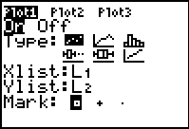
- Use  to determine the weight of the baby at 1.5 years and 3 years.

- How will you know if your estimate is a good one?

- Do children continue to grow at the same rate throughout childhood and into the teenage years? How do you think this will affect the graph?

Problem 3 – Shark Attack!
Have you ever heard of the term “fork length”? Run the SHARK program and explain why you think that name was given to that length.  Two different types of thresher sharks have total body lengths and “fork” lengths as follows:  (212 cm, 192 cm) and (373 cm, 211 cm) | 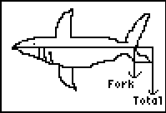
- Find the slope.

- What is the equation for the shark’s lengths?

Graph your equation and a scatter plot of the two known points. (See Problem 2 for steps.)
- Use  to make a prediction of the fork length for a Thresher shark that has a total length of 400 cm.

- Do you agree or disagree with the following statement? Explain why.
The longer the total length of the shark, the longer the fork length is.

- Do you think that the weight of the shark would be related to the length of the shark? How would it relate?

