Topic 2.6 Competing Function Model Validation | Residuals
Practice Problem 1
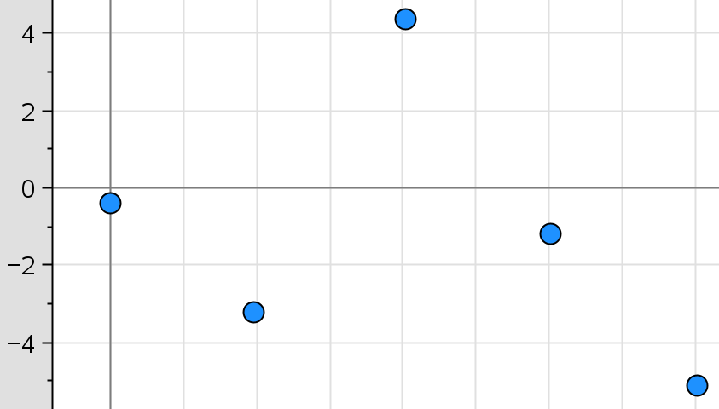
Residuals
Time

A new comedian has joined social media. The number of followers since the comedian created a social media account is recorded. An exponential regression was used to develop a model for the number of followers over time. The figure shows a graph of the residuals of the exponential regression. Which of the following statements about the exponential model is true?
(a) The residual plot has no apparent pattern, so the exponential model was appropriate.
(b) The residual plot has no apparent pattern, so the exponential model was not appropriate.
(c) The residual plot displays a pattern, so the exponential was appropriate.
(d) The residual plot displays a pattern, so the exponential model was not appropriate.

Practice Problem 2
A regression model is constructed for a data set. One of the data points is (1, 8). The residual value corresponding to this data point is 0.5.
(a) The predicted value when x = 1 is 8.5 and is an overestimate.
(b) The predicted value when x = 1 is 8.5 and is an underestimate.
(c) The predicted value when x = 1 is 7.5 and is an overestimate.
(d) The predicted value when x = 1 is 7.5 and is an underestimate.

Practice Problem 1 Solution:
(a) The residual plot has no apparent pattern, so the exponential model was appropriate.
A model is justified as appropriate for a data set if the residuals of a regression, the residual plot, appear without pattern.
Practice Problem 2 Solution:
(d) The predicted value when x = 1 is 7.5 and is an underestimate.
The residual is the actual value – the predicted value. If the residual value is positive, the predicted value is an underestimate.
0.5 = 8 – predicted value; therefore, the predicted value is 8 – 0.5 = 7.5
**Note: This activity has been developed independently by Texas Instruments. AP is a registered trademark of the College Board, which was not involved in the production of, and does not endorse, this product. Policies subject to change. Visit www.collegeboard.org.

