Open the TI-Nspire™ document One_Year_Makes_A_ Difference.tns.  In this activity, you will construct and interpret box plots and histograms of data to draw informal comparative inferences about two populations. You will examine given bench press data, height data, and shuttle run data. | 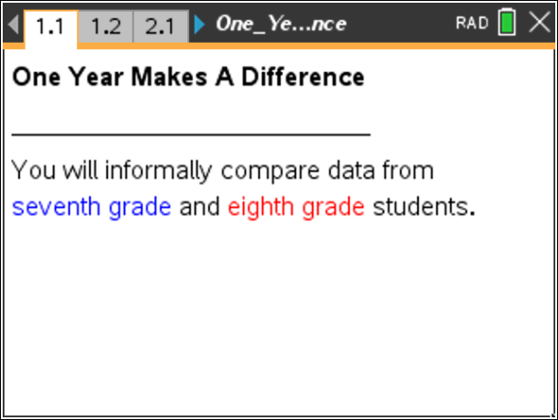

1. The table below shows bench press strengths of 20 seventh grade male students and twenty eighth grade male students collected at the beginning of a strength-training unit in Physical Education. Does this data suggest any differences in the seventh and eighth grades? Compute and compare the minimums, medians, and maximums to support your answer.

7th Grade  Bench Press (lbs) |  |  |  | 8th Grade  Bench Press (lbs)
84 | 98 | 112 | 120 | 82 | 106 | 116 | 126
88 | 98 | 114 | 120 | 94 | 106 | 122 | 126
90 | 102 | 116 | 124 | 98 | 110 | 124 | 128
94 | 104 | 118 | 124 | 100 | 110 | 124 | 136
94 | 108 | 118 | 132 | 104 | 112 | 124 | 162

Move to page 1.2.

2. The variables grade8_bp and grade7_bp are stored in this document, so you can select them to be plotted on the coordinate axes. To display a box plot, follow these steps:
- Select the add variable text at the bottom of the page, and select the variable grade7_bp.
- Select MENU > Plot Properties > Add X Variable and select the variable grade8_bp.
- Select MENU > Plot Type > Box Plot.
- Move the cursor over each part of the box plots to reveal the values for the five number summaries.

Tech Tip: Tap the add variable box on the x axis and then select the variable grade7_bp. Select  > Plot Properties > Add X Variable and select the variable grade8_bp. Then create the box plot by selecting > Plot Type > Box Plot. > Plot Properties > Extend Box Plot Whiskers can also be selected.

3. Explore the box plots, and answer the following questions:
a. Find the five number summaries for the data sets and record them in the table below.

Grade | Minimum  (lbs) | Lower Quartile  (lbs) | Median  (lbs) | Upper Quartile  (lbs) | Maximum  (lbs)
7th
8th

b. Describe the similarities and differences in the five number summaries and the box plots.

c. Describe any differences you find between the 7th grade and 8th grade data using the five number summaries and the box plots.

4. Suggest other plots that could be used to compare these sets of data.

5. Change the Box Plot to a Histogram by selecting MENU > Plot Type > Histogram.
Tech Tip: Change the Box Plot to a Histogram by selecting > Plot Type > Histogram. Note that in some cases, a student may need to back-out to the main Tools Menu to see the desired menu option.
6. Describe the histograms. What are the most frequent intervals for each data set? What are the overall shapes and positions of the distributions? Explain your reasoning.

Move to page 2.1.

7. Do you think that young women grow much between the start of seventh grade and the start of eighth grade? The table on the next page contains the heights in inches measured at the start of each school year. Recall the interquartile range (IQR) is the difference between the upper and lower quartile while the range is the difference between the maximum value and minimum values of a data set.

Seventh Grade  Height (in.) |  |  |  | Eighth Grade  Height (in.)
55 | 56 | 61 | 65 | 59 | 64 | 66 | 67
56 | 57 | 61 | 65 | 60 | 64 | 67 | 68
56 | 57 | 63 | 65 | 60 | 65 | 67 | 69
56 | 57 | 63 | 67 | 61 | 65 | 67 | 69
56 | 59 | 63 | 67 | 62 | 65 | 67 | 69

a. Compute the five number summary, the interquartile range, and the range for each data set, and record them below.

Grade | Minimum | Lower Quartile | Median | Upper Quartile | Maximum | Interquartile Range | Range
7th
8th

b. Does this data suggest that there is a difference between the heights? Support your answer using the data found in the table.

8. Create box plots for the data as before, and verify the computations for the five number summaries, the interquartile ranges, and the ranges. What does the box plot show, if anything, that the computed statistics did not? Explain.

9. Now construct and describe the histograms for these data sets. Compare the shapes of the histograms. Are there gaps or clusters? Explain your reasoning.

Move to page 3.1.

10. Do you think that young men get much faster between the start of seventh and the start of eighth grade? The table below contains the shuttle run times in seconds measured at the start of each school year.

Seventh Grade  Shuttle Run (sec) |  |  |  | Eighth Grade  Shuttle Run (sec)
6.0 | 7.9 | 9.0 | 12.9 | 6.3 | 7.3 | 8.2 | 9.0
6.3 | 8.1 | 9.3 | 13.1 | 6.5 | 7.7 | 8.4 | 9.3
7.0 | 8.1 | 10.0 | 13.6 | 7 | 8.0 | 8.5 | 9.6
7.1 | 8.2 | 11.7 | 13.6 | 7.1 | 8.1 | 8.6 | 10.
7.5 | 8.8 | 12.3 | 14.2 | 7.3 | 8.1 | 9.0 | 10.5
a. Compute the five number summary, the interquartile range, and the range for each data set, and record them below.

Grade | Minimum | Lower Quartile | Median | Upper Quartile | Maximum | Interquartile Range | Range
7th
8th

b. Does this data suggest that there is a difference between the times? Support your answer using the data in the table and the relative sizes of the interquartile ranges and the ranges.

11. Create box plots for the data, and verify the computations for the five number summaries, the interquartile ranges and the ranges. What does the box plot show, if anything, that the computed statistics did not? Explain.

12. Create the histograms, and then describe them. Compare the shapes of the histograms. Are there gaps or clusters? Explain your reasoning.

13. Adjust the bin widths of the histograms by selecting MENU > Plot Properties > Histogram Properties > Bin Settings > Equal Bin Width. Change the bin width to 0.25. What is the impact on gaps and clusters?

Tech Tip: Adjust the bin widths of the histograms by selecting > Plot Properties > Histogram Properties > Bin Settings > Equal Bin Width. Then select the cell for “Width” and type in 0.25.

