Open the TI-Nspire document Ratios_of_Similar_Figures.tns.  In this activity, you will explore the will explore the ratio of perimeter, area, surface area, and volume of similar figures in two and three dimensional figures. |  |  |  |  |  | 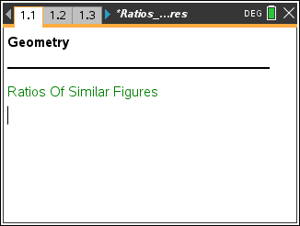  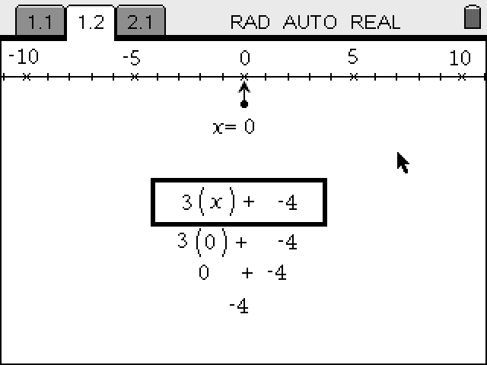
Move to pages 1.2: This page sets the stage for the activity. |  |  |  |  |  |  | 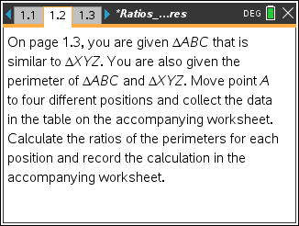
On page 1.3, you are given ABC that is similar to XYZ. You are also given the perimeter of ABC and XYZ.  - Move point A to 4 different positions and collect the data in the table below. Calculate the ratios of the perimeter of XYZ to perimeter of ABC for each position and record the calculation in the table below. |  |  |  |  |  |  | 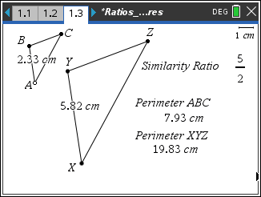
 | Position | AB | XY | Perimeter of XYZ | Perimeter of ABC |  |  | Ratio of Perimeters  (Round to 2 decimals)
 | 1
 | 2
 | 3
 | 4

2. What is the similarity ratio of the two triangles written in the form a : b?

3. What is the ratio of the perimeters of the two triangles in the form a : b?

4. How are the similarity ratio and the ratio of the perimeters related?

On page 1.9, you are given ABC that is similar to XYZ. You are also given the area of ABC and XYZ.
5. Move point A to 4 different positions and collect the data in the table below. Calculate the ratios of the perimeter of XYZ to perimeter of ABC for each position and record the calculation in the table below.
Position | AB | XY | Area of XYZ | Area of ABC | Ratio of Areas  (Round to 2 decimals)
1
2
3
4

6. What is the ratio of the areas of the two triangles in the form a : b?

7. How are the similarity ratio and the ratio of the areas related?

Problem 2 – Similar Figures | 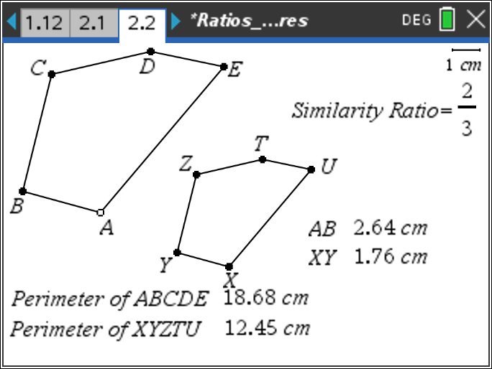

On page 2.2, you are given pentagon ABCDE that is similar to pentagon XYZTU. You are also given the perimeter of ABCDE and XYZTU.
8. Move point A to 4 different positions and collect the data in the table below. Calculate the ratios of the perimeter of pentagon XYZTU to perimeter of pentagon ABCDE for each position and record the calculation in the table below.
Position | AB | XY | Perimeter of XYZTU | Perimeter of ABCDE | Ratio of Perimeters  (Round to 3 decimals)
1
2
3
4

9. What is the similarity ratio of the two pentagons written in the form a : b?

10. What is the ratio of the perimeters of the two pentagons in the form a : b?

11. How are the similarity ratio and the ratio of the perimeters related?

On page 1.9, you are given pentagon ABCDE that is similar to pentagon XYZTU. You are also given the area of ABCDE and XYZTU.
12. Move point A to 4 different positions and collect the data in the table below. Calculate the ratios of the perimeter of pentagon XYZTU to perimeter of pentagon ABCDE for each position and record the calculation in the table below.
Position | AB | XY | Area of XYZTU | Area of ABCDE | Ratio of Areas  (Round to 3 decimals)
1
2
3
4

13. What is the ratio of the areas of the two triangles in the form a : b?

14. How are the similarity ratio and the ratio of the areas related?

15. If the similarity ratio of two similar figures is a : b, then the ratio of the perimeters is ____________.

16. If the similarity ratio of two similar figures is a : b, then the ratio of the areas is ____________.

Problem 3 – Extension to Three-Dimensional Figures | 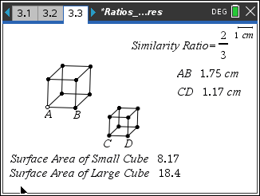

For this problem, we will look at three-dimensional figures and the ratio of the surface area and volume of two similar figures.
On page 3.3 you are given two similar cubes. You are also given the length of one side of each cube.
17. Move point A to 4 different positions and collect the data in the table on the accompanying worksheet. Calculate the ratios of the surface areas for each position and record the calculation in the table below.
Position | AB | CD | Surface Area of Small Cube | Surface Area of Large Cube | Ratio of Surface Areas  (Round to 3 decimals)
1
2
3
4

18. What is the similarity ratio of the two cubes written in the form a : b?

19. What is the ratio of the surface areas of the two cubes in the form a : b?

20. How are the similarity ratio and the ratio of the surface areas related?

On page 3.9, you are given two similar cubes. You are also given the length of one side of each cube. | 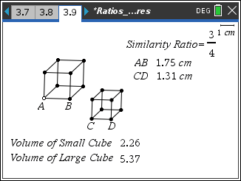

21. Move point A to 4 different positions and collect the data in the table on the accompanying worksheet. Calculate the ratios of the volumes for each position and record the calculation in the table below.

Position | AB | XY | Volume of Small Cube | Volume of Large Cube | Ratio of Volumes  (Round to 6 decimals)
1
2
3
4

22. What is the ratio of the volumes of the two cubes in the form a : b?

23. How are the similarity ratio and the ratio of the volumes related?

24. If the similarity ratio of two similar figures is a : b, then the ratio of the surface areas is ___________.

25. If the similarity ratio of two similar figures is a : b, then the ratio of the volumes is ___________.

