Open or create the TI-Nspire document Scale_Factor_Area_Perimeter.tns.  The relationship of the scale factor and area and perimeter of similar triangles will be explored by dragging a vertex of a triangle. Additional observations will be made after changing the scale factor. | 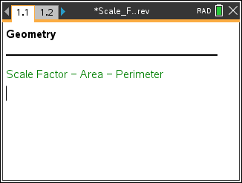

Move to page 1.2. | Press / ¢ and / ¡ to navigate through the lesson.
ΔAB'C' was constructed by dilating ΔABC through point A with the given scale factor of 2. Therefore, ΔABC ~ ΔAB'C'. | 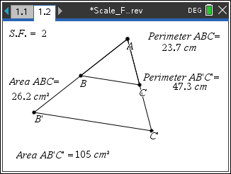
1. Move point A. Describe the changes that occur as you move the point.

2. Suppose that point A is moved such that the measure of is 5, is 7, and is 4. What would the measures be for each of the corresponding segments on ΔAB'C'? Justify your answer.
AB' = _____, B'C' = _____, AC' = _____

3. Complete the table below by moving point A to three locations.
Scale Factor 2 | Similar Δ’s Pair 1 | Similar Δ’s Pair 2 | Similar Δ’s Pair 3
Perimeter ΔABC
Perimeter ΔAB'C'
Area ΔABC
Area ΔAB'C'

4. Use the measurements recorded in the table above to make relative comparisons of the perimeters of ΔABC and ΔAB'C'.
5. Use the measurements recorded in the table to make relative comparisons of the areas of ΔABC and ΔAB'C'.

6. Predict what will happen to the relative comparisons of the perimeters and areas if the scale factor is changed.

7. To complete the table below, do the following:  a. Change the scale factor to 3 and move point A to three different locations.  b. Change the scale factor to and move point A to three different locations.  To change the scale factor, move the cursor over the current scale factor of 2 located in the upper-left corner of the screen. Double-click. The cursor is now inside the text box. Press . and type the new scale factor. Then press ·. |  | 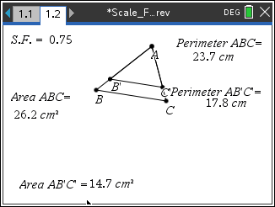
Scale Factor 3 | Similar Δ’s Pair 1 | Similar Δ’s Pair 2 | Similar Δ’s Pair 3
Perimeter ΔABC
Perimeter ΔAB'C'
Area ΔABC
Area ΔAB'C'

Scale Factor | Similar Δ’s Pair 1 | Similar Δ’s Pair 2 | Similar Δ’s Pair 3
Perimeter ΔABC
Perimeter ΔAB'C'
Area ΔABC
Area ΔAB'C'

8. Using the perimeter and area measurements recorded for ΔABC above for Similar Δ’s Pair 1, give the following measurements for ΔAB'C' if the scale factor is 5.
Perimeter ΔAB'C' =______; Area ΔAB'C' = ______.
9. Make a conjecture about the relative comparison of the perimeters of the similar triangles if the scale factor is r.

10. Make a conjecture about the relative comparison of the areas of the similar triangles if the scale factor is r.

