Exploring the Data
What happens when the domain and range of a function trade places? This special "trade" creates inverses of functions, which will be explored in this activity.
Below is wind tunnel data obtained from www.doe.state.la.us.  Wind tunnel experiments are used to test the wind friction or resistance of an automobile at different speeds. The given data shows wind speed in miles per hour versus resistance in pounds.  Record this data in L1 and L2 by pressing S and select Edit. Make sure to clear the lists before you input any data.
  Speed (MPH) | Resistance (lbs.)
  10 | 6.4
  21 | 9.2
  34 | 17.0
  40 | 22.4
  45 | 30.2
  55 | 59.2
1. Construct a scatter plot and graph your data on the grid below. Recall that to construct a scatter plot, press ` !, select the scatter plot option, and make sure that L1 and L2 are selected for Xlist and Ylist. Press # and select the ZoomStat option.  2. Now graph a second scatter plot on your calculator (Plot 2) and graph the new data on the grid above. For this graph, you will switch the domain and range. This means that in the StatPlot menu, L1 and L2 trade places. | 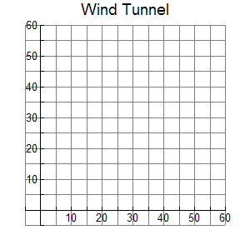
Exploring the Problem
3. After graphing the original wind tunnel data and then graphing the data with the domain and range switched, what did you notice about the graphs of the two sets of points?

4. Find the midpoint between the first points from the first and second scatter plots and the midpoint of the last points from the first and second scatter plots.

5. Find the equation of the line that connects these two midpoints. Graph this line on the grid above and on your calculator. What does this line represent?
Developing the Pattern Further
Clear all data in L1 and L2. Also, clear all plots; Plot1, Plot2, and Y1.

6. Graph y = 2x +3 in a standard viewing window. Use the zero command (` $) to find the x-intercept. Use $ to find the y-intercept.

7. Switch the locations of the x- and y-coordinates of these points to (y, x) and input these as L1 and L2. Graph these two points using Plot1. Find the equation of the line connecting these two points and graph it in Y2.

8. Switch x and y in the equation y = 2x + 3 and solve for y. How does your result compare to your answer to Question 7?

9. List 3 ways in which the inverse of a function may be obtained.

10. The inverse of a function is always a function.  Agree  Disagree
Explain your answer choice and provide at least one example to illustrate why you chose it.

11. Find the inverse of the following functions if an inverse exists. If an inverse does not exist, write “does not exist.”
Function | Inverse
 | f ^{–1}(x) =
 | f ^{–1}(x) =
| | f ^{–1}(x) =

