Open the TI-Nspire™ document PermutationsandCombinations.tns | 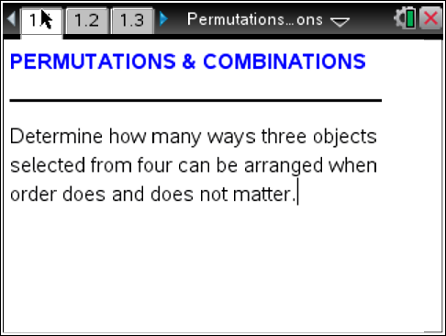

Read the instructions on pages 1.1 and 1.2 and move to page 1.3.
Problem 1 – Arranging Letters
On pages 1.3–1.7, there are sets of four letters, ABCD. For each row, select three of the four letters and arrange them in the left box. Each arrangement of letters should be different than the previous arrangements.
For example, ABC is different than BCA.
Repeat until you have found all arrangements. Record your arrangements here.

Each of these arrangements is known as a permutation. To find permutations of a set, objects are arranged in a way such that the order of the objects matters.
The notation for permutations is _{n}P_{r}, where n is the total number of objects and r is the number of objects selected. You can use the following formula to find the total number of permutations:
Use this formula to find out how many ways you can select 3 letters from 4 letters when the order matters. Does this match the number of arrangements you found above?

Read the directions on page 2.1 and move to page 2.2.
Problem 2 – Arranging Letters in a Different Way
On pages 2.2 to 2.5, there are sets of four letters, ABCD. For each row, select three of the four letters and arrange them in the left box. Each arrangement of letters should be different than the previous arrangements. However, the order of the letters does not matter for this problem.
For example, ABC is not different than BCA.
Repeat until you have found all arrangements. Record your arrangements here.

Each of these arrangements is known as a combination. To find combinations of a set, objects are arranged in a way such that the order of the objects does not matter.
The notation for permutations is _{n}C_{r}, where n is the total number of objects and r is the number of objects selected. You can use the following formula to find the total number of permutations:
Use this formula to find out how many ways you can select 3 letters from 4 letters when the order does not matter. Does this match the number of arrangements you found above?

Move to page 3.1.
Problem 3 – Permutation versus Combination
Answer the following questions.
- Selecting five cards from a standard deck of cards is an example of a combination. True or false?

- Selecting three letters for a license plate is an example of a combination. True or false?

- Which expression has a larger value, ₅C₃ or ₅P₃?

- Why are there more arrangements when calculating a permutation than a combination?

Extension – Handshake Problem
If each person in a group shakes hands with every other person in the group, how many handshakes occur?
On pages 4.3–4.7, connect the pairs of points (representing people) with a segment until all points are connected to each of the other points. The number of segments equals the number of handshakes. Record your results here.

- Is this a combination or permutation? Why?

- How many handshakes occur if there are n people?

