Open the TI-Nspire document One_And_One_Equals_Win.tns.  Probability is a part of our lives. Meteorologists may predict “a 30 percent chance of rain.” Car insurance rates are based on the probabilities of different genders and age groups having accidents. In this activity, you will use proportionality and a basic understanding of probability to make and test conjectures about the results of experiments and simulations. | 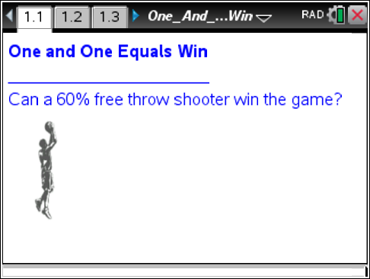

Let’s review probability before answering the question on Page 1.1.
1. What is experimental probability?

2. Give an example of experimental probability.

3. What is theoretical probability?

4. Give an example of theoretical probability.

Move to page 1.2.

Your teacher will divide the class into groups. On Page 1.2, you see a spinner divided into a blue area and a red area. You will use the spinner to compare experimental and theoretical probabilities for landing in the red area representing 60% of the area of the circle.
- The slider p stands for the probability the spinner will land in the red region which is measured as a percent.
- You can use the slider to change the percentage of the area shaded red, and you can use the right arrow to spin.
5. Begin by dragging the slider to the right from p = 0 to p = 100. Record your observations.

6. Move the slider so p=60. Record the following information into the table below:
- Predict the number of times out of 10 spins that the spinner will land on red.
- Spin the spinner 10 times, and record the results in the table. One person can spin, and another person can record the spins landing on red with tallies and total the tallies.
- Calculate the experimental probability for your group.
- Calculate the theoretical probability for P(60).
- After the class outcomes have been recorded, record the total number of class spins landing in the red area.
- Calculate the experimental probability for the class.

P(red) | Predicted Outcomes Landing on Red | Actual Outcomes Landing on Red | Your Group Experimental Probability | Theoretical Probability | Actual Class Outcomes | Class Experimental Probability
60%

7. After each group has reported their results and the table is complete, compare and contrast the outcomes generated by your group with the class outcomes. Which set of outcomes were closer to the theoretical and why?

Berryville High School is playing Harrison High School for the State Basketball Championship. The score is 78-79 in favor of Berryville High School. With one second left, a player from Berryville High School fouls Terry, a player from Harrison High School. Terry is a 60% free throw shooter, and he goes to the line for a “one and one” foul shot situation. Is the game likely to end in a tie, a win, or a loss for Harrison High School?
8. Record your prediction whether the game will end in a win, a loss, or a tie below.

Prediction _________________________

Move to page 1.3.

9. Be sure the slider percentage is set to 60.
- Click the Δ to begin the trial.
- If the shot is a miss, the game is lost, and it’s time for a new trial.
- If the shot is made, a message appears to click Δ to take a second shot.
- Repeat this process for ten trials. The results of the trials are recorded and totaled on Page 1.3.
- To conduct another set of trials, click Reset to set the Trial counter to 0.
10. Record your group results in the table below, and calculate the experimental probabilities:
Group Results:
Trials | 10
 |  | Experimental Probabilities
Losses
Ties
Wins

11. After the class results have been aggregated, record those results in the table below, and calculate the experimental probabilities:
Class Results:
Trials
Experimental Probabilities
Losses
Ties
Wins

12. Compare and contrast the class results from the 60% spinner simulation and the class results from the simulation for the 60% free throw shooter:
Similarities:

Differences:

13. Do you want to change your prediction of whether the game will end in a win, a loss, or a tie for Harrison High School? Please record your current prediction about the outcome of the basketball game between Berryville and Harrison High below.

Prediction______________________

In addition to simulations, area models are often used to predict outcomes of real world events. Since our problem involves percentages, a 10 x 10 grid would be a good model for us to consider.

Read the directions on page 1.4 and move to page 1.5.

14. The previous simulations provided data we used to compare experimental and theoretical probabilities. Now, we want to consider theoretical probabilities with an area model. Out of 100 attempts to make the first free-throw shot, we expect a 60% free throw shooter to miss ________ shots.

15. Move the P(loss) slider to represent the missed shots on the first attempt. What does the model currently show?

16. Out of 60 attempts to make the second shot of a “one and one” situation, how many shots do we expect a 60% free throw shooter to miss?

17. Move the P(tie) slider to represent the number of shots missed on the second attempt of the “one and one” situation. How does the model represent the 60% free throw shooter?

18. Out of 60 attempts to make the second shot of a “one and one” situation, how many shots do we expect a 60% free throw shooter to make?

19. Move the P(win) slider to represent the number of shots made on the second shot of the “one and one” situation. How does the model represent the 60% free throw shooter?

20. What type of probability was represented by the area model? Why?

