Open the TI-Nspire document Equations_from_Unit_Rates.tns.  In this activity, you will find the linear equation for a proportional situation, and you will find ordered pairs from the graph of the linear equation. Your group will also create and present a story about a proportional situation and use technology to provide mathematical representations for the story to the rest of the class. | 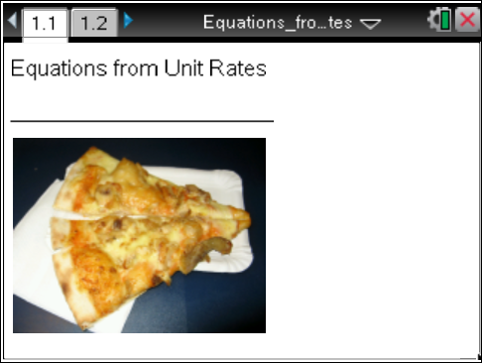

Move to page 1.2. | Press / ¢ and / ¡ to navigate through the lesson.
1. Suppose you can buy two pieces of pizza for $2.50. Compute the unit rate, and use that to see how much x slices would cost. Write the expression for the cost of x slices.

2. Enter your expression in the entry line for f1(x). If the entry line is not visible, press / G. Press · to graph the equation.

3. Describe the graph of the equation. What is the slope for your graph?

4. Identify some points this line passes through. Use the Trace tool of TI-Nspire to display numerical values based upon the equation. Describe how these values fit the proportional situation. Reminder: In order to trace the graph, press b, and select Trace. Next select Graph Trace. Press · to mark points from Trace.

5. Use Function Table option of TI-Nspire in order to display numerical values based upon the equation. Explain what the values of pairs represent in the situation. Reminder: In order to display function table, press / T.

6. Your group will now create a real-life story that represents a proportional situation. In this story, you can not use the unit rate to describe the situation, but you can use the ratio of two variables. You can then use the ratio to analyze the relationship between the two variables. Record your story in the space below.

Open a New Document, and Select Graphs App.

7. Find an equation that describes the relationship in your story. Record your equation. Is this a proportional situation? Explain.

8. Enter your equation into f1 in the entry line. Press · to graph the equation. Describe the graph of the equation. What is the slope for your equation? Explain.

9. Use either the Trace option or the Function Table of TI-Nspire in order to display ordered pairs based upon the equation. List at least four ordered pairs of values based on your equation.

10. Describe how these ordered pairs fit the story.

