Open the TI-Nspire document Particle_Motion_1.tns.  This activity models the motion of a particle along a straight, horizontal line. You will examine the relationship among the position of the particle, the velocity of the particle, and the cumulative distance traveled by the particle. | 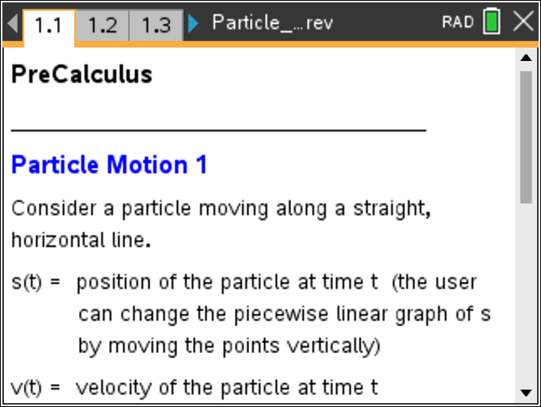

Move to page 1.2.

- For measured in seconds, is the position of the particle at time , is the velocity of the particle at time , and is the cumulative distance traveled by the particle from time
- The values of , , and are given in the left panel on Page 1.3 and Page 1.4.
- The slider arrows are used to change the value of .
- The graph of is displayed on Page 1.3, and the graph of is shown on Page 1.4. The motion of the particle along the horizontal line is modeled in the top panel on both pages.
Move to page 1.3.

1. Use the slider arrows to change the value of or grab and drag the open circle on the horizontal axis. Observe the relationship among the position of the particle (), the cumulative distance traveled (), and the velocity of the particle (). Complete the following table.

 | 0 | 1 | 2 | 3 | 4 | 5 | 6 | 7 | 8 | 9 | 10

2. To explore how the motion of the particle along a horizontal line is related to the position graph begin by setting As you slowly move the point to the right, watch how the particle moves along the horizontal line at the top of the page.
a. On what time intervals is the particle moving to the right? Describe the behavior of the graph of on these intervals.

b. On what time intervals is the particle moving to the left? Describe the behavior of the graph of on these intervals.

c. Are there any time intervals on which the particle is stationary? If so, describe the behavior of the graph of on these intervals.

3. To explore how the position graph is related to the velocity graph begin by setting seconds. For each time interval, find the velocity of the particle, the slope of the corresponding line segment of the graph of and the direction of the particle motion (left or right).

Time Interval | Velocity | Line Segment Slope | Direction

a. Make a conjecture about how the velocity of the particle is related to the slope of the position graph.

b. Make a conjecture about the sign (positive or negative) of the velocity and the direction of particle motion (left or right).

c. How would you change the graph of in order for the magnitude of the velocity to increase? Decrease? Grab and move some of the points on the graph of to check this conjecture.

Move to page 1.4.

4. Explore the relationship between the graph of the velocity, the cumulative distance, and the position of the particle.
a. What is the cumulative distance at time seconds? Find the area of the rectangle bounded by the graph of and the horizontal axis over the interval How do these two values compare?

b. Find the area of the rectangle bounded by the graph of and the horizontal axis over the interval
- Add this area to the area found in part (a). How does this sum compare to the cumulative distance at time t = 4?

- Subtract this area from the area found in part (a). How does this difference compare to the position of the particle at time t = 4?

c. Find the area of the rectangle bounded by the graph of and the horizontal axis over the interval
- Add this area to the cumulative distance at time t = 4. How does this sum compare to the cumulative distance at time t = 6?

- Subtract this area from the position of the particle at time t = 4. How does this difference compare to the position of the particle at time t = 6?

d. Explain how to use the graph of to find the cumulative distance at times t = 8 and t = 10 and find these values.

e. Explain how to use the graph of to find the position of the particle at times t = 8 and t = 10 and find these values.

f. Explain why the cumulative distance is the sum of areas (associated with the graph of the velocity function) but the position of the particle is dependent upon the sign of the velocity (or signed area).

