Open the TI-Nspire document Normal_Probability_Plot.tns or use the create document to create the .tns file.  Normal probability plots help determine whether a data set is approximately normal by plotting expected z-scores vs. the data value. You will investigate the shape of histograms and the association between the data values and the respective expected z-scores to determine whether the distribution of a given data set is approximately normal. | 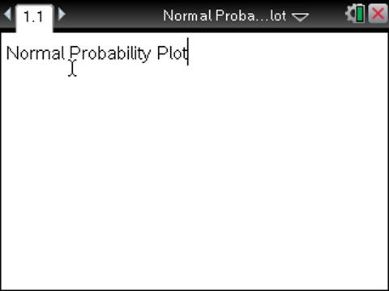

The data below were taken from a random sample of high school males. Normal probability plots help determine whether a data set is approximately normal by plotting expected z-scores vs. the data value. You will investigate the shape of histograms and the association between the data values and the respective expected z-scores to determine whether the distribution of a given data set is approximately normal.
Survey data from random sample of males
Height (in) | 73 | 74 | 71 | 67 | 69 | 71 | 72 | 70 | 69 | 72 | 71 | 69 | 71
Handspan (cm) | 20.5 | 20.5 | 18.75 | 20 | 19.5 | 20.5 | 20.25 | 20.5 | 17 | 20.5 | 20.5 | 16 | 18
Shoe Size (cm) | 32 | 30 | 31 | 29.5 | 31 | 29 | 39 | 32.5 | 31 | 32 | 30 | 30.5 | 31

Move to page 1.3. | Press / ¢ and / ¡ to navigate through the lesson.
Tip: Hovering over a bin in a histogram or a point in a normal probability plot will display the data.
1. a. Describe the distribution of the heights of the males. Explain your answer.

b. Plot the mean for the male heights by selecting b > Analyze > Plot Value. Use the alphabet keys to type mean(height), and press ·. Now find the standard deviation by selecting b > Analyze > Plot Value. Use the alphabet keys to type stdevsamp(height), and press ·. Write down the mean and the standard deviation.

c. Would you consider the distribution of male heights to be approximately normal based on the shape of the histogram and the mean and standard deviation? Explain your reasoning.

Move to page 1.4.

Note: Clicking on the line will display the equation of the line.
2. a. The plot on Page 1.4 is called a normal probability plot. Move the cursor to one of the points. What do the coordinates represent?

b. Describe the association between the height and the expected z-scores displayed in the graph.

c. Based on your answer to question 1b, make a conjecture about the association seen in a normal probability plot and approximately normal data.

Move to page 1.5.

3. Page 1.5 shows the distribution of a random sample of male handspands measured in centimeters.
a. Describe the distribution of the handspans. Explain your answer.

b. Based on the normal probability plot for heights, make a conjecture about the normal probability plot for the handspans. Do you think it would be similar or different? Explain your answer, and make a sketch.

Move to page 1.6.

4. Page 1.6 displays the normal probability plot for the handspans. Does the graph support your conjecture in 3b? Describe the graph.

Move to page 1.7.

5. Describe the distribution of the lengths of male shoe sizes in cm.

6. Based on the normal probability plots for heights and handspans, make a conjecture about the normal probability plot for the shoe sizes compared to the normal probability plots for the heights and for the handspans. Explain your thinking, and make a sketch of what you think the plot will look like.

Move to page 1.8.

7. Page 1.8 displays the normal probability plot for shoe sizes. Does the plot support your conjecture in question 6? Describe the graph.

Move to page 1.9.

The dot plot at the top of the screen displays the distribution of the weight (in pounds) of a random sample of 20 high school males. The bottom of the screen displays the normal probability plot generated from the male weights.
8. a. Move the points in the dot plot until the normal probability plot in the lower window is approximately linear. Describe the dot plot.

b. Move the points in the dot plot until the normal probability plot is concave up. Describe the dot plot.

c. Move the points in the dot plot until the normal probability plot is concave down. Describe the dot plot.

9. a. In this activity, you looked at distributions that were approximately symmetric and mound-shaped, skewed left, and approximately symmetric and mound-shaped with an apparent high outlier. If you knew the normal probability plot was approximately linear, what can you conclude about the original data set?

b. What would a normal probability plot look like for an approximately normal distribution with a low outlier? Explain your answer.

