Problem 1 – The General Radical Function
Graph the equation. Once graphed, use $ to observe the coordinate values for points on the graph.  This graph was created with the GridLine on and # ZDecimal. Press ` # for format to turn on GridLine.  - What is the domain and range of the function?  - Why does the graph “stop” at the origin?  - When is the following statement true? The graph of the square root function is completely in the first quadrant.  Always Sometimes Never | 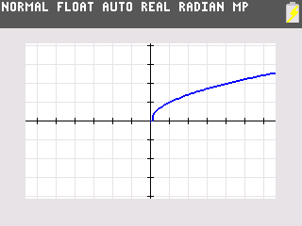  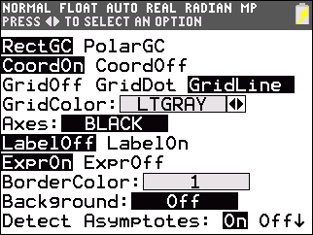
Problem 2 – Transformations
Start the Transformation Graphing application by pressing A and selecting Transfrm.  Now, press ! and enter A√(X–B)+C into Y1.  Press #, select ZStandard. Press @ and change the Xres to 3 to make it graph faster. Press %. Notice the displayed equation. The values of A, B and C may be changed by using the arrow and number keys. Explore the transformations.  4. What does the graph look like when all three variables equal zero? Why? | 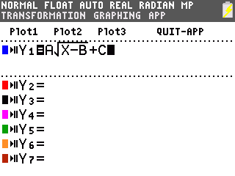
5. Based on your exploration, when is the following statement true? The graph of the square root function is completely in the first quadrant.  . Always Sometimes Never | 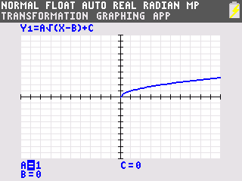
Continue to manipulate the values of A, B and C on the graph to help answer Questions 6–16.
6. Find two functions whose domain is x ≥ 3.

7. What is the domain of the function f(x) = ? Check using the graph.

8. Changing which variable will create a horizontal shift?

9. Find two functions whose range is y ≥ –2.

10. What is range of the function f(x) = ? Check using the graph.

11. Changing which variable will create a vertical shift?

12. What is the difference between the graphs of f(x) = and g(x) = ?

13. What is the difference between the graphs of f(x) = and g(x) = ?

14. What effect does the variable a have on the graph?

15. What is the domain of the function using the general equation ?

16. What is the range of the function using the general equation ?

Extension – Cube Root Functions
Press ! and enter into Y1.  Press m and select for the cube root.  Change the values of the variables A, B, and C, and observe the effects of the changes on the graph.  17. What is the domain and range of the function in terms of the general equation? | 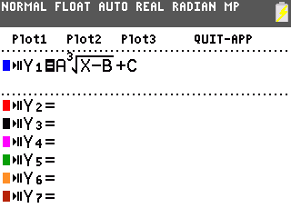
18. Describe the effects of changing each variable on the graph. | 