Problem 1 – A Binomial Experiment
1. When rolling a die, what is the theoretical probability of rolling a “3”?

2. When a die is rolled 100 times, how many times do you expect that a “3” will be rolled?

Simulate 75 experiments of rolling a die 100 times and recording the number of successes where a success is rolling a “3,” by doing the following:  Press m, choose randBin( from the PRB menu. Type in the number of trials per experiment, the probability of a success, and the number of experiments. Then press  and L1 to store the results in list 1. Press . | 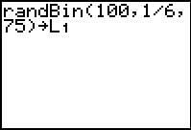
The calculator will take 1-2 minutes to perform the simulations. When it is completed, the beginning of the list of the number of successes per trial will appear. A result of 18 means that out of 100 rolls, a “3” came up 18 times. | 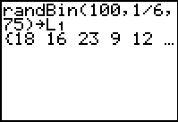
Press . Select 1-Var Stats from the CALC menu and then enter L1 on the home screen.  3. What is the mean of the data set (to one decimal place)?  4. What is the standard deviation (to one decimal place)? | 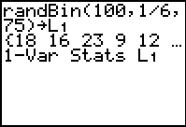
Press  , turn Plot 1 on, choose the graph type to be a histogram, and L1 to be the XList. | 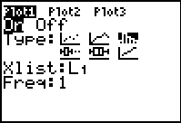
Press  and choose ZoomStat to view the histogram.  5. Describe the shape of your histogram.  Press . The min and max of each interval is shown.  6. Where does the mean occur? | 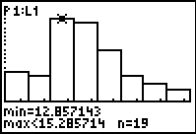
Press . Change the Xscl to the standard deviation of the data set. Press  again. Go back and change other scales, such as Ymax until all the bars, and the top of each bar, are in the viewing window. | 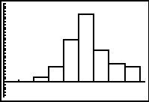
Press  to see the number of values in each interval. List each interval, the number of data values in that interval (n), and the percent of data values in that interval (calculate n/75).

7. What percent of the values occur in the middle two intervals? the middle four intervals? the middle six intervals? (Note: These are only estimates. Add an interval with n = 0 if needed. Use symmetry to determine which side of the graph to place it.)

8. How do your results compare to the results of other students? Make a conjecture.

Problem 2 – Properties of the Normal Curve
Press  and choose ZoomStat again. Notice that if a smooth curve were drawn through the tops of the bars, the curve would resemble a bell. This curve is called a normal, or bell, curve, and it is used to approximate binomial distributions for a large number of trials. A normal curve has several interesting properties.
Turn the histogram off. Press  and set the values as shown at the right. | 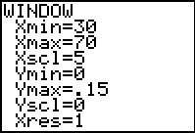
Press □, choose normalpdf( ( ). Enter X, 50, 5 to graph a normal distribution with a mean of 50 and a standard deviation of 5.  Press .  9. Where is the mean located? | 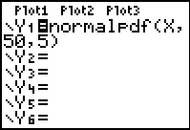
Press □, and make Y2 = normalpdf(X, 50, 3) to graph a normal distribution with a mean of 50 and a standard deviation of 3.  10. How does it compare to Y1, the distribution which has a mean of 50 and a standard deviation of 5? | 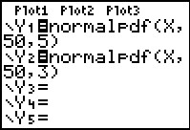
Graph a third distribution with a mean of 50 and a standard deviation greater than 5.
11. How does it compare to Y1? Make a conjecture.

Delete the rules for Y2 and Y3. Make Y2 = normalpdf(X, 45, 5) to graph a normal distribution with a mean of 45 and a standard of 5.  12. How does it compare to Y1, the distribution which has a mean of 50 and a standard deviation of 5? | 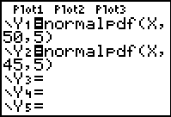
Graph a third distribution with a standard deviation greater than 5 and a mean greater than 50.
13. How does it compare to Y1? Make a conjecture.

14. To summarize: What affects the center of the distribution? What affects the width?

Problem 3 – The Empirical Rule
The area under any normal curve is 1 because it represents 100% of the data.  Press   to return to the home screen. Press   and select Shadenorm( from the DRAW menu. Type 45, 55, 50, 5 to shade and show the area of a normal curve with a mean of 50 and standard deviation of 5 which falls between 45 and 55. That is, the area under the curve that falls within one standard of the mean. | 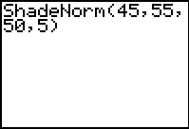
15. What is this area?

16. To the nearest whole percent, what percent of the curve lies with one standard deviation of the mean?

Go back to the home screen and repeat the procedure above to answer the following.
17. To the nearest whole percent, what percent of the curve lies within two standard deviations of the mean?

18. To the nearest tenth of a percent, what percent of the curve lies within three standard deviations of the mean?

19. Use your calculator and the answers above to write in approximate percents for each interval (3 standard deviations above and below the mean). Remember that the distribution is symmetric about the mean, so 50% is above the mean and 50% is below the mean.
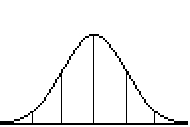

A normal distribution always follows these same percents. Return to question 7 (Problem 1). Were your percents close to those of a normal distribution?

