Cell Respiration
Cell respiration refers to the process of converting the chemical energy of organic molecules into a form immediately usable by organisms. Glucose may be oxidized completely if sufficient oxygen is available and is summarized by the following reaction:
C₆H₁₂O₆ + 6 O₂(g) 6 H₂O + 6 CO₂(g) + energy
All organisms, including plants and animals, oxidize glucose for energy. Often, this energy is used to convert ADP and phosphate into ATP. It is known that pea seeds undergo cell respiration during germination. Do pea seeds undergo cell respiration before germination? Using your collected data, you will be able to answer this question concerning respiration and non-germinated peas.
Using the CO₂ Gas Sensor, you will monitor the carbon dioxide produced by pea seeds during cell respiration. Both germinated and non-germinated peas will be tested. Additionally, cell respiration of germinated peas at two different temperatures will be tested.

OBJECTIVES
In this experiment, you will
- Use a CO₂ Gas Sensor to measure concentrations of carbon dioxide during cell respiration.
- Study the effect of temperature on cell respiration rate.
- Determine whether germinating peas and non-germinating peas respire.
- Compare the rates of cell respiration in germinating and non-germinating peas.

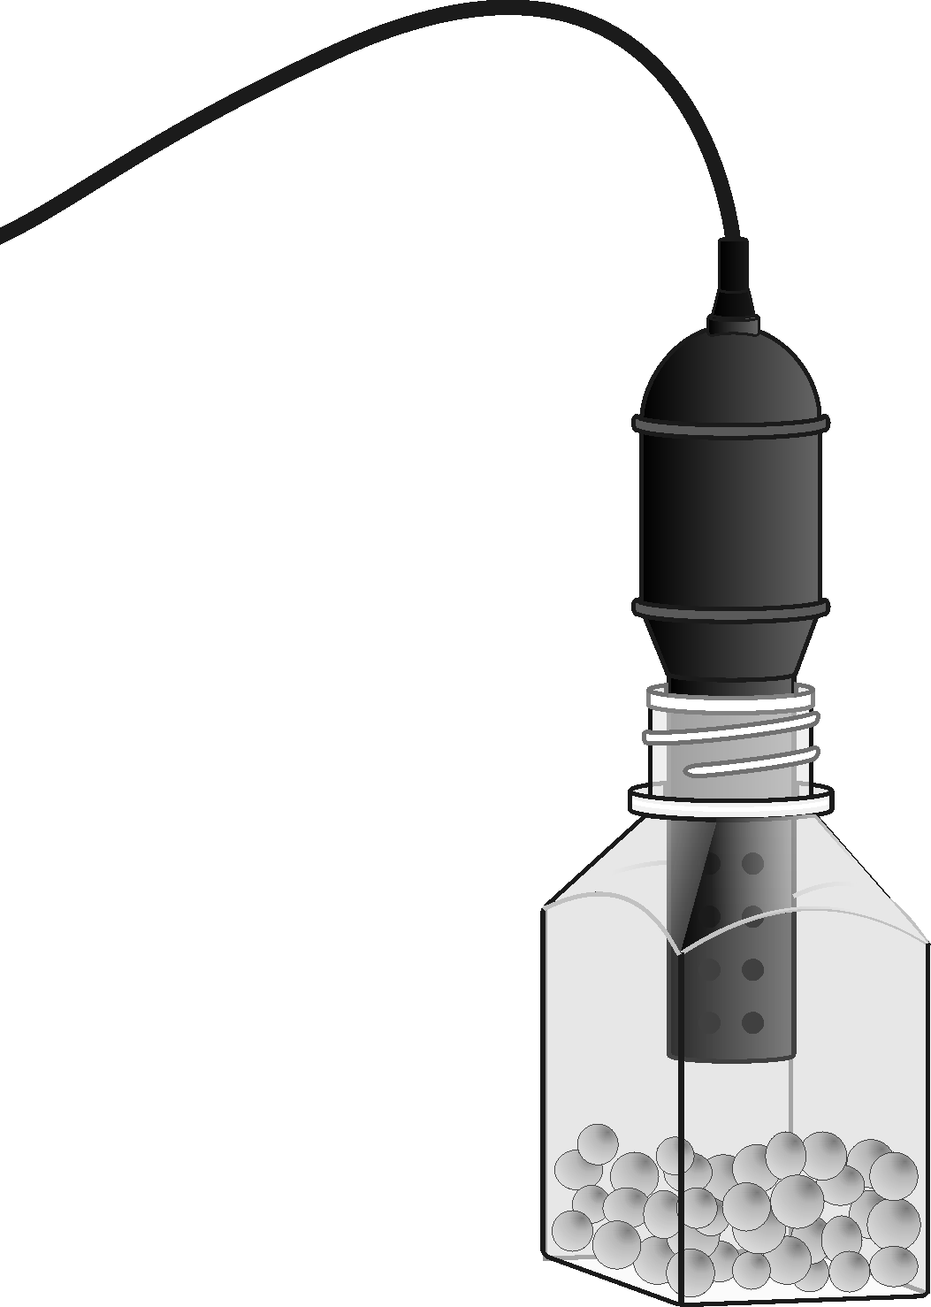
Figure 1

MATERIALS
TI-Nspire handheld or | 250 mL respiration chamber
computer and TI-Nspire software | 25 germinated pea seeds
data-collection interface | 25 non-germinated pea seeds
Vernier CO₂ Gas Sensor | ice cubes
100 mL beaker | thermometer
PROCEDURE
1. If your CO₂ Gas Sensor has a switch, set it to the Low (0–10,000 ppm) setting. Connect the sensor to the data-collection interface. Connect the interface to the TI-Nspire handheld or computer.
2. Choose New Experiment from the Experiment menu. Choose Collection Setup from the Experiment menu. Enter 300 as the experiment duration in seconds. The number of points collected should be 76. Select OK.
3. Measure the room temperature using a thermometer and record the temperature in Table 1.
4. Obtain 25 germinated pea seeds and blot them dry between two pieces of paper towel.
5. Place the germinated peas into the respiration chamber.
6. Place the shaft of the CO₂ Gas Sensor in the opening of the respiration chamber.
7. Wait one minute, then start data collection (). Data will be collected for 300 seconds.
8. When data collection has finished, a graph of carbon dioxide gas vs. time will be displayed.
9. Remove the CO₂ Gas Sensor from the respiration chamber. Place the peas in a 100 mL beaker filled with cold water and an ice cube. The cold water will prepare the peas for part II of the experiment.
10. Use a notebook or notepad to fan air across the openings in the probe shaft of the CO₂ Gas Sensor for 1 minute.
11. Fill the respiration chamber with water and then empty it. Thoroughly dry the inside of the respiration chamber with a paper towel.
12. Determine the rate of respiration.
- Examine the graph and identify the most linear region and select the data points in the most linear region.
- Choose Curve Fit ►Linear from the Analyze menu.
- Record the slope, m, as the rate of respiration in ppm/s in Table 2.

13. Click the Store Data button () to save the first run data. Repeat Steps 5–12 substituting the germinated peas with non-germinated pea seeds. In Step 9 place the non-germinated peas on a paper towel and not in the ice bath.
Part II Germinated peas, cool temperatures
14. Remove the germinated pea seeds from the cold water and blot them dry between two paper towels.
15. Click the Store Data button () to save the second run data. Repeat Steps 5–12 using the cold peas.
16. Graph all three runs of data on a single graph.
- Click run3 and select All. All three runs will now be displayed on the same graph axes.
- Use the displayed graph and Tables 1 and 2 to answer the questions below.

DATA
Table 1
Room Temperature (°C)

Table 2
Peas | Rate of respiration  (ppm/s)
Germinated, room temperature
Non-germinated, room temperature
Germinated, cool temperature

Questions
1. Do you have evidence that cell respiration occurred in peas? Explain.
2. What is the effect of germination on the rate of cell respiration in peas?
3. What is the effect of temperature on the rate of cell respiration in peas?
4. Why do germinated peas undergo cell respiration?

extensionS
1. Compare the respiration rate among various types of seeds.
2. Compare the respiration rate among seeds that have germinated for different time periods, such as 1, 3, and 5 days.
3. Compare the respiration rate among various types of small animals, such as insects or earthworms.

