Activity Overview  In this activity, students find z-scores and critical values to test claims about proportions. To verify the results, they find P-values by finding the area under the curve using the ShadeNorm command and lastly by using the 1-PropZTest command.  Topic: Hypothesis Testing  - Use the sampling distribution of a proportion to test the null hypothesis H₀: p = p₀ against the alternative one-tailed hypothesis H_{a}: p < p₀ or the two-tailed hypothesis H_{a}: p ≠ p₀  Teacher Preparation and Notes  - Students should already be familiar with the basic concepts behind hypothesis testing and have knowledge of binomial experiments and the requirements for a binomial experiment.  - This activity is intended to be mainly teacher-led, with breaks for individual student work. Use the following pages to present the material to the class and encourage discussion. Students will follow along using their graphing calculators.  - Depending on time available, Problems 1 and 2 can be done in class and Problem 3 can be completed for homework.  - To download the student worksheet, go to education.ti.com/exchange and enter “10130” in the keyword search box.  Suggested Related Activities  To download any activity listed, go to education.ti.com/exchange and enter the number in the keyword search box.  - Estimating a Population Proportion (TI-84 Plus family) — 9985  - Claims About Two Proportions (TI-Nspire technology) — 10259  - Difference Between Two Proportions (TI-84 Plus family) — 10081  - Candy Pieces (TI-84 Plus family) — 100397 | 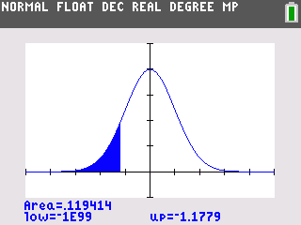  This activity utilizes MathPrintTM functionality and includes screen captures taken from the TI-84 Plus C Silver Edition. It is also appropriate for use with the TI-83 Plus, TI-84 Plus, and TI-84 Plus Silver Edition but slight variances may be found within the directions.  Compatible Devices:  - TI-84 Plus Family  - TI-84 Plus C Silver Edition  Associated Materials:  - TestingClaimsAboutProportions_Student.pdf  - TestingClaimsAboutProportions.doc  Click HERE for Graphing Calculator Tutorials.

Problem 1 – Lefties
Discuss how hypothesis testing can be used to test claims about proportions, and that the test statistic is z, given that the requirements for a binomial experiment are met.
Students are told to test the claim that 10% of Americans are left-handed. Confirm with students that z can be used as the test statistic.
Have students write null and alternative hypotheses. This is a two-tailed test.
Students are directed to calculate the sample proportion, , where x is the number of successes, in this case, left-handed students. Students should round to 6 decimal places.  Ask students if they think 6% is far enough away from 10% to reject the claim. | 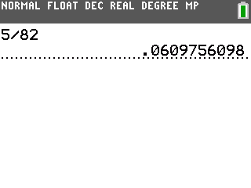
Students will calculate the test statistic. Have students avoid rounding by using the fraction template (  ).  Watch for students who accidentally use the sample proportion in the denominator. | 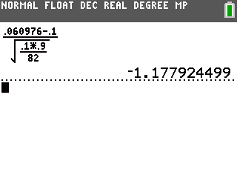
Next, students are to calculate the critical values. Because it is a two-tailed test, students will need to divide 0.05 by 2. Because the normal distribution is symmetric, they can just find the left critical value and use its opposite for the right critical value. | 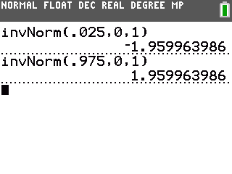
Discuss with students if they should reject or fail to reject the 10% claim for the students at this school.
The test statistic is not in either critical region, so we fail to reject the null hypothesis.
Instruct students to find the P-value by using the ShadeNorm command. Have students make sure that all functions and plots have been turned off. This command will find the area under the curve beyond the test statistic. This is about 11.94%.
Because the test is two-tailed, this value is doubled to find the P-value. The P-value is about 23.9%, much greater than 5%, so it was correct to fail to reject the null hypothesis. | 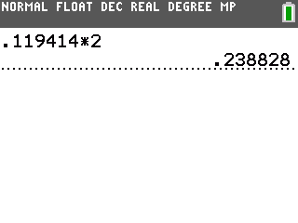
Problem 2 – Loaded Cube
Students are introduced to the loaded number cube scenario. Confirm that the requirements for a binomial experiment are met.  Have students find decimal approximations for both p, the claimed population proportion, and, the sample proportion.  Students are to determine their null and alternative hypotheses for this right-tailed test. | 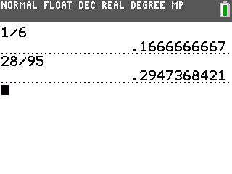
Students are to calculate the test statistic and the critical value. Because this is a right-tailed test, all of the 0.01 is to the right of the critical value.  Discuss with students if they should reject or fail to reject the claim that sixes come up more than they should.  The test statistic is in the critical region, so we reject the null hypothesis. Sixes are coming up more than expected. | 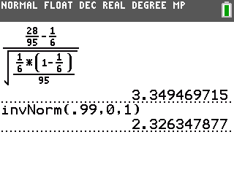
Students are to find the P-value. Before using the ShadeNorm command, students will need to use the ClrDraw command from the DRAW menu ().
The area is about 0.000405. The value is not doubled because it is a one-tailed test. Because it is less than the significance level of 0.01, it was correct to reject the null hypothesis.
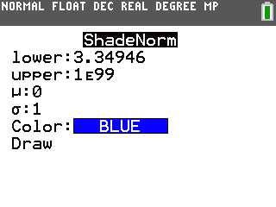 | 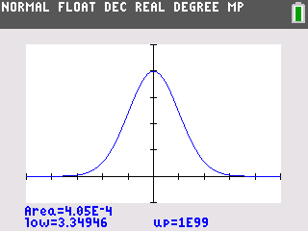

Problem 3 – Cats and Dogs
For the scenario, students should work independently to write the null and alternative hypotheses.  Students are to determine the sample proportions,  z-scores, and critical values. Walk around and help students as needed during this time. | 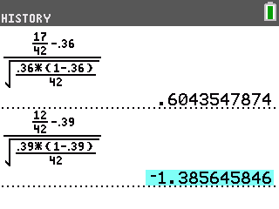
Discuss with students if they should reject or fail to reject the claims about the proportions for cats and dogs in this neighborhood at α = 0.10.  Neither test statistic is beyond a critical value. There is not enough evidence to reject either claim. | 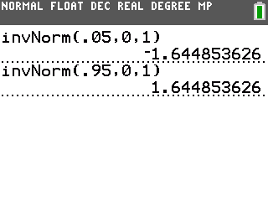
Students are to use the 1-PropZTest command to find the P-values for each test. The P-values are about 0.55 and 0.17, both above 0.10, the significance level. | 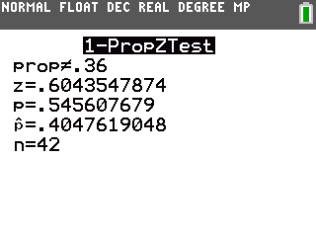
Solutions
1. ,
2. =
3. z = –1.178
4. Critical values are –1.96 and 1.96.
5. Fail to reject, the test statistic is not in the critical region.
6. Area under curve is 0.119414.
7. P-value = 0.238828
8. It is greater than 5%, so it was correct to fail to reject the null hypothesis.
9. p =
10. =
11. This is a right-tailed test: ,
12. z = 3.34946
13. Critical value is 2.32635.
14. The test statistic is in the critical region, so reject the null hypothesis. Sixes are coming up more than expected.
15. P-value = 0.000405; It is less than 0.01, the significance level used.
16. Cats: , ; Dogs: ,
17. Cats: p = 0.404762; Dogs: p = 0.285714
18. Cats: = 0.604356; Dogs: = –1.38565
19. Critical values are –1.64485 and 1.64485.
20. Cats: Fail to reject, the test statistic is not in the critical region.
Dogs: Fail to reject, the test statistic is not in the critical region.
21. Cats: 0.545608; Dogs: 0.165855
22. The P-values are both above the significance level of 0.10.

